**[Project Name]**

[Client] | Updated [Month Day, Year]

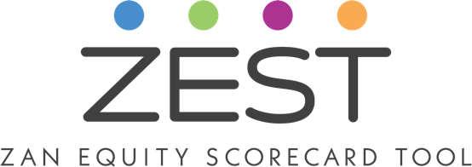

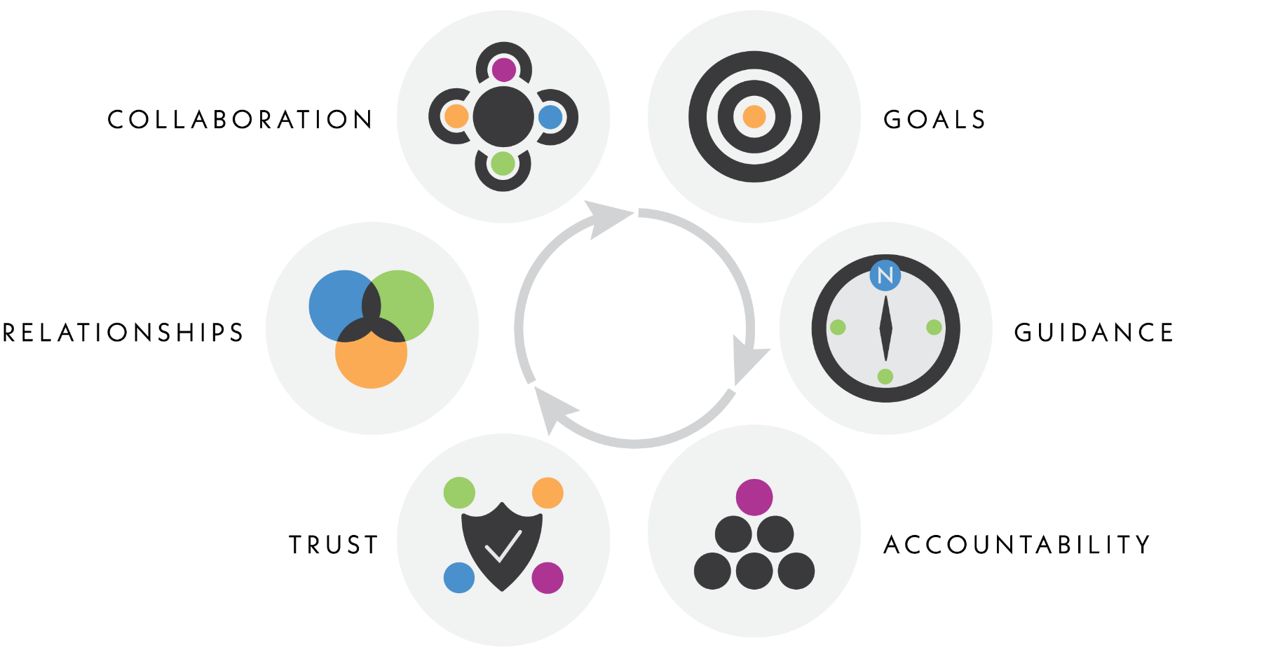

# Equity Commitments

1. Everyone affected by a decision has a right to be involved, and we strive to engage all people.
2. Everyone has a valid opinion, and we respect and actively listen to people.
3. We go where people are. We do not expect them to come to us.
4. People engage, learn and receive information in many ways, so we us a variety of strategies and tactics.
5. We seek out local knowledge and contacts (cultural, neighborhood and business) to collaborate and better serve our communities.
6. We give and gather information in multiple ways to provide all invested people access.
7. We learn from our experiences and hold ourselves accountable to our goals.

# Equity Groups to Consider

Race and ethnicity are key parts of people’s identities. However, they are not the *only* identities to consider in our equity work. Also consider:

* Age
* Ability
* Religion
* Cultural Customs
* Housing access and tenure
* Income
* Gender/preference
* Language and Linguistic Diversity
* Technology Access/Skill
* Education
* Geography
* Race/Ethnicity

# Scorecard

Answer all the questions in each section based on the goals of the project, research you do online, conversations with colleagues, and conversations with people in your communities. For each question you answer, give yourself one point. Once complete, add up your score and see where you fall in the Scoring Rubric at the end of the document. As you learn more information, update your scorecard to improve your equity score.

|  |  |  |  |  |
| --- | --- | --- | --- | --- |
| **Category** | **Questions** | **Prompt** | **Responses** | **Score** |
| **Project Basics** | Who/what inspired the project and how is it being funded? | Understanding why the project started and the funding source helps explain the balance of power and expectations. |  |  |
| What is the objective of this project? | Describe the goals of the project in plain language. |  |  |
| What should success look like for the agency and partner organizations if the goals are met? | Imagine what your project looks like at completion if all goes well. How will the project be received by your staff internally? |  |  |
| What should success look like if the goals are met for the community? | How will people behave? What benefits will arise? Who will be pleased? Who will benefit? How will the community be left better than when the project started? |  |  |
| What groups might not be in favor of or benefit from the decision/objectives? | It is important to uncover those that may not be in favor of the project and why, to hear their reasoning and address the issues thoughtfully. Are there any potential roadblocks? |  |  |
| **Community Profile** | What is the racial, social, age and economic, etc. makeup of the project area? | Use online demographic sources, census information, existing plans, etc. to learn about the area. Be thorough; review the Equity Groups to Consider section above for all groups to consider. |  |  |
| What is important to know about the communities in the project area? | This question may take a bit of research if you’re not familiar with the area. Search online, speak to various leaders in the community, places of worship, and organizations and talk to school staff and colleagues. Consider: Historical disparities? Environmental impacts on certain populations? Transportation or mobility issues? Historic distrust of authority? Engagement fatigue? |  |  |
| Who are the key leaders in the community that could/should be engaged? | Find people and organizations who are deeply engaged with the community. Learn from them about the community. It’s important to note the sovereign nations[1] in the area and how you will connect on the project. |  |  |
| What key organizations can partner in this project? | Focus on underrepresented groups. |  |  |
| What/where are the key places in the community to plan engagement based on the sociodemographic? | Focus on groups who may not attend open houses and public hearings. How might we meet them in places we’re already gathering? |  |  |
| **Stakeholders** | Who are the key decision makers for the project? | Understanding who has the power to make important decisions during the project will provide insight into where to gather information, which voices have the most weight, and what other voices may need to be elevated and to whom. It will also tell you who determines process, engagement, funding, construction plans, etc. |  |  |
| Who are the primary stakeholders who will be directly affected by the project? | If this project is completed as planned, who will be affected by the objectives on a day-to-day basis? Commuters? Residents? Businesses? Families? |  |  |
| Who are the stakeholders who will be indirectly affected by the project? | These are community members who may not be directly affected but interested/invested in the project. Agencies, advocates, organizations, neighboring areas, businesses, etc. |  |  |
| What historically excluded/untapped groups need to be targeted for engagement? | Consider which groups may have been ignored, uninvited, distrustful in the past and should now be involved in the project. |  |  |
| Who will benefit from the project? | Consider each group that will benefit via money, power, education, safety, access, health, etc. |  |  |
| **Engagement** | What data should be collected during engagement? | Consider what you want to know and how you will get it. Are you using multiple modalities? How will the data guide your planning/decision making? |  |  |
| How should the project engage community members? | Write this in plain language. Make a list of the tasks related to the scope. Track your progress and complete these tasks. |  |  |
| How will you adjust engagement strategies according to the communities? | How will the ethnicity, socioeconomic status, language, transportation use, access to housing, gender, age, and ability of your communities influence how you do engagement? |  |  |
| What decisions should be influenced by the public? | Keep these ideas at front of mind. These will help guide your engagement planning. |  |  |
| Should the engagement goal be to inform, consult, involve, collaborate or empower the public? Explain. | Reference the Spectrum of Participation chart below. Understanding the goal of your project will help guide the best engagement strategies. |  |  |
| **Communication** | How should the project share objectives and key messages to the public?[2] | Commit to using clear, plain language and various modalities. Provide opportunities for the public to ask questions and provide feedback. Be sure to provide updates during the projects as things progress and change. |  |  |
| Are all stakeholders aware of and have a clear understanding of the goals and objectives (particularly at the beginning of the project?)? | How will you ensure all community members/stakeholders, not just some or the easiest to reach, understand the objective of the project? How will it be communicated in a way that everyone can have access to the information? |  |  |
| How should we keep a consistent feedback loop with your communities (input in, information out)? | People want to know they have been heard. Once you hear from them and make decisions, let them know how their voice mattered. |  |  |
| How should different communication strategies and languages be utilized to reach communities? | Consider using translator services, technology and non-technology tools, virtual and in-person, etc. |  |  |
| How should you build trust with your communities? | Are your efforts to reach all stakeholders genuine? If you are unsuccessful in one attempt, how are you adjusting? Are you creating safe spaces for all? |  |  |
| **Reflection**  *Answered at the end of the plan development* | Has the project met its intended outcomes so far? | The following questions are important to help you look back on what worked and didn’t, where changes need to be made for next time, and how you have grown. |  |  |
| What have been the successes of the project? | Keep track for future use. |  |  |
| What have you learned from this project? | Reflect and set new goals for your next project. |  |  |
| How did you close the feedback loop? | For accountability and relationship building. |  |  |
| What leaders or groups could be future partners/continued relationships? | Critical for building a strong network and future engagement work. Record these in Vantage Point. |  |  |
|  |  |  | **TOTAL** | **0** |

# Scoring

|  |  |  |
| --- | --- | --- |
| **Range** | **Progress** | **Suggestions** |
| **27 - 30** | Exemplary work on your equity-focused actions and efforts! You are well-prepared for successfully implementing an equitable plan and have shown excellent initiative and thoughtful care for this work. You are moving toward true inclusion and awareness. Because of your commitment to equity, the communities you serve will have an important voice in the happenings in their schools. When you commit to engaging and empowering all, you are one step closer on the journey to social justice. Thank you! | Continue to use your position to uplift those who have been historically untapped and give voice to those generally not asked to speak. |
| Continue to gather information and resources from your communities. Take note of where you have been successful and your work is supporting the communities you serve. |
| Keep the scorecard handy throughout the plan so you are able to refer to it regularly. The more you refer to it and answer the questions, the more natural it will be to stay equity-focused in all of your work. |
| **23- 26** | Good effort on your equity-focused plan/project! You most likely made a positive impact on the communities you serve. Your plan is on track; however, you could use some additional information and effort in preparing your plan. Consider returning to this document to add information as you go, it will be a benefit to your plan. Thank you for your dedication. | Ask community representatives if they could help provide more information about the area. Do some investigating into the history, demographics and culture. As you gather information, update your scores. |
| Continue to learn more about the communities and neighborhoods that you serve. Grow your contact list as well as your engagement strategy repertoire. |
| Deepen your connections with contacts and reach out to those who can teach you more about the communities you serve. |
| **Less than 23** | You are beginning to see equity as a priority in your work. Using this scorecard will help you to consider the many ways you can make an impact on the communities you serve. You have identified some important information in your responses but there is still more work to do. Learning to be equity-focused is a journey and progress is made by small steps in the beginning. Thank you for your efforts around equity. | Do more research or connect with additional people to gather information. Consider how you could talk to colleagues, community members and others to learn more about the area. Read up and research about different cultural groups in your area. |
| Keep your scorecard front and center as you work. Research the answers to as many questions as possible. Don’t be afraid to ask for support. |
| Focus on reviewing your actions through a lens of empathy and interest as you move forward to ensure you are promoting the voices of all. |

# Spectrum of Public Participation[3]

|  |  |  |  |  |  |
| --- | --- | --- | --- | --- | --- |
|  | **Inform** | **Consult** | **Involve** | **Collaborate** | **Empower** |
| **Public Participation Goal** | To provide the public with balanced and objective information to assist them in understanding the problem, alternatives, opportunities, and solutions. | To obtain public feedback on analysis, alternatives and decisions. | To work directly with the public throughout the process to ensure that the public concerns and aspirations are consistently understood and considered. | To partner with the public in each aspect of the decision including the development of alternatives and identification the preferred solution. | To place final decision making in the hands of the public. |
| **Promise to the Public** | We will keep you informed. | We will keep you informed, listen to and acknowledge concerns and aspirations, and provide feedback on how the public input influenced the decision. | We will work with you to ensure that your concerns and aspirations are directly reflected in the alternatives developed and provide feedback on how public input influenced the decision. | We look to you for advice and innovation in formulating solutions and incorporate your advice and recommendations into the decisions to the maximum extent possible. | We will implement what you decide. |

1. **Sovereign nations:** Tribes were already self-governing in commerce, traditions and with the physical land before colonization. They have inherent sovereignty. Tribes are Nations. A [Tribal Nation](https://www.dot.state.mn.us/tribaltraining/tribe-map.html) has a right to self-govern, to determine its own way of life and to live that life on lands as freely as possible from outside interference. Consider connecting with the associated tribal nation for your project to gather input and or collaboration.
2. **Key messages:** A limited number of succinct statements that draw people into the project and why they should participate*.*
3. **Spectrum of public participation:** [IAP2’s Spectrum of Public Participation](https://cdn.ymaws.com/www.iap2.org/resource/resmgr/pillars/Spectrum_8.5x11_Print.pdf)was designed to assist with the selection of the level of participation that defines the public’s role in any public participation process. The Spectrum is used internationally, and it is found in public participation plans around the world.