[SCHOOL OR COMMUNITY NAME]

SAFE ROUTES

TO SCHOOL
A plan to make walking and biking to school a safe, fun activity

Infrastructure Engineering projects that improve streets and routes

INFRASTRUCTURE RECOMMENDATIONS
Use this space to highlight takeaways from your infrastructure map to the right. Focus on SMART recommendations that are Specific, Measurable, Achievable, Relevant, and Time-bounded, and that address equity—the overarching E of Safe Routes to School planning.
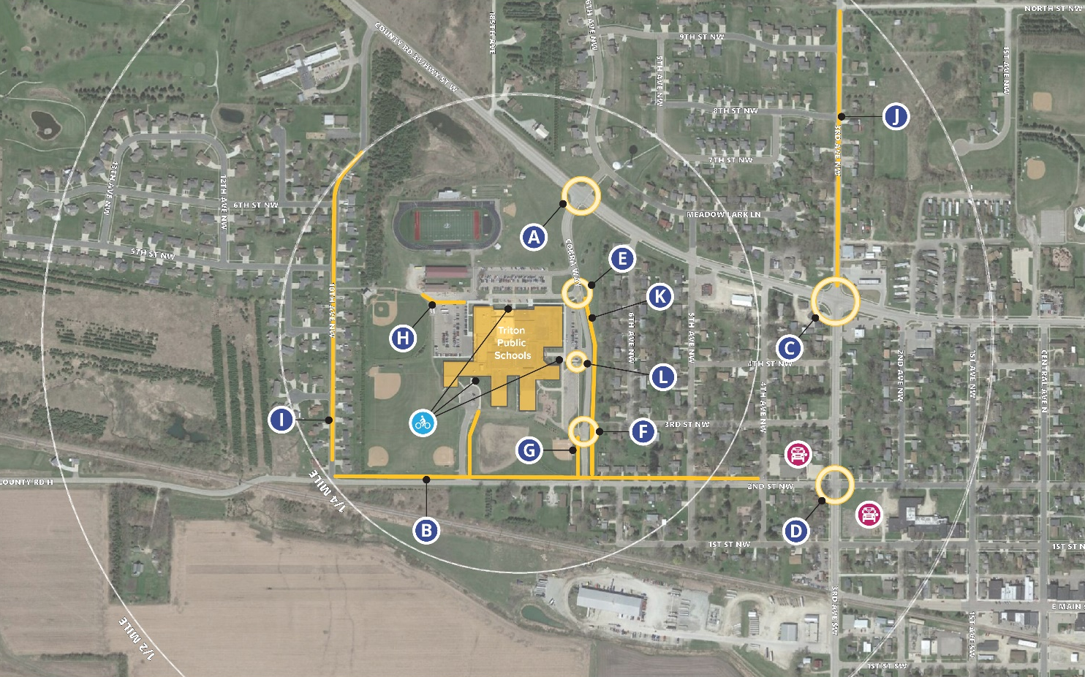

Programs Equity + Education + Encouragement + Engagement + Evaluation
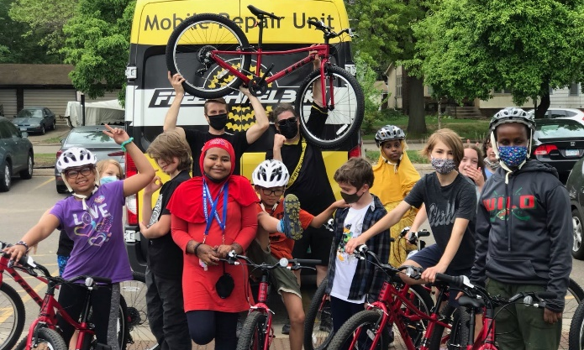

Program Name
How will this be implemented?
Why is this relevant and recommended?
How will this address transportation inequities?
Who needs to be involved to make this happen?
What is the timeline for implementation?

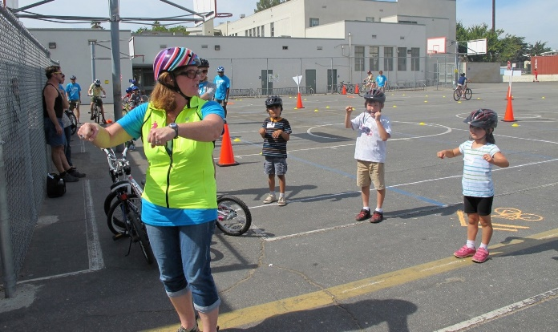

PROGRAM NAME
How will this be implemented?
Why is this relevant and recommended?
How will this address transportation inequities?
Who needs to be involved to make this happen?
What is the timeline for implementation?
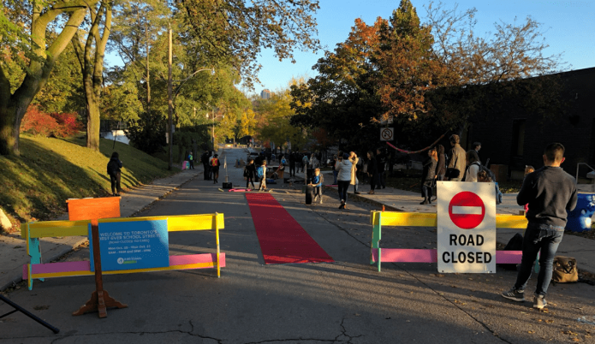

PROGRAM NAME
How will this be implemented?
Why is this relevant and recommended?
How will this address transportation inequities?
Who needs to be involved to make this happen?
What is the timeline for implementation?

Get Involved
Want to help make it safer, easier, and more comfortable to walk and bike to school in [community name]? Contact your school principal or SRTS lead to learn how to get involved.
[Team lead + contact information]
Learn more about Safe Routes to School at: www.dot.state.mn.us/saferoutes/

