[SCHOOL OR COMMUNITY NAME]

SAFE ROUTES

to SCHOOL
A plan to make walking and biking to school a safe, fun activity

Programs equity + Education + Encouragement + evaluation

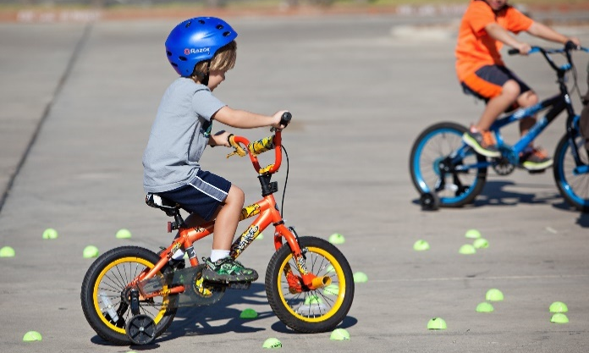

Program Name
What: [Brief explanation. Two lines of text maximum for formatting]
Who: [One line of text]
How: [One line of text]
When: [One line of text]

PROGRAM NAME
What: [Brief explanation. Two lines of text maximum for formatting]
Who: [One line of text]
How: [One line of text]
When: [One line of text]

Program Name
What: [Brief explanation. Two lines of text maximum for formatting]
Who: [One line of text]
How: [One line of text]
When: [One line of text]

Program Name
What: [Brief explanation. Two lines of text maximum for formatting]
Who: [One line of text]
How: [One line of text]
When: [One line of text]

Program Name
What: [Brief explanation. Two lines of text maximum for formatting]
Who: [One line of text]
How: [One line of text]
When: [One line of text]

Program Name
What: [Brief explanation. Two lines of text maximum for formatting]
Who: [One line of text]
How: [One line of text]
When: [One line of text]

Infrastructure Routes + street projects

INFRASTRUCTURE RECOMMENDATIONS
Use this space in whatever way works best for your project.
It could be used for additional images, a caption, map legend, or narrative explaining recommendations. Or maybe you have an infrastructure image that really looks best in portrait orientation.
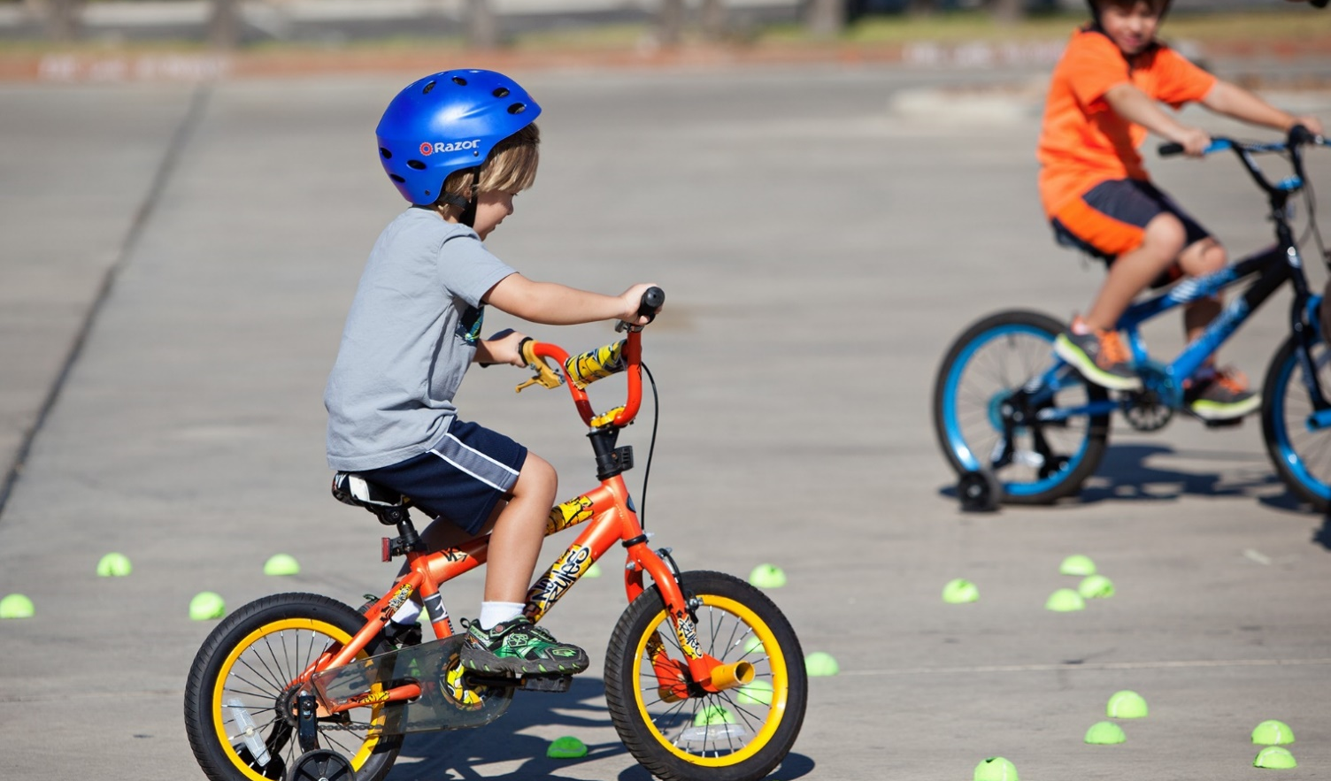

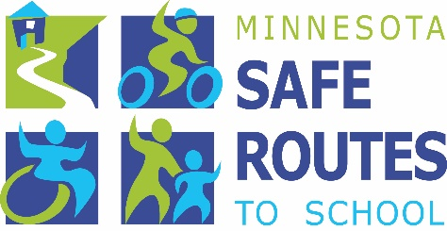
GET INVOLVED
Plan your walking or biking route with your student, watch for students and respect school zone speed limits, and show your support by volunteering! Contact your school principal to learn how you can get involved.
Learn more about Safe Routes to School at: www.dot.state.mn.us/saferoutes/

Contact
[Name, Title]
[Organization]
[Email]
[Phone]

